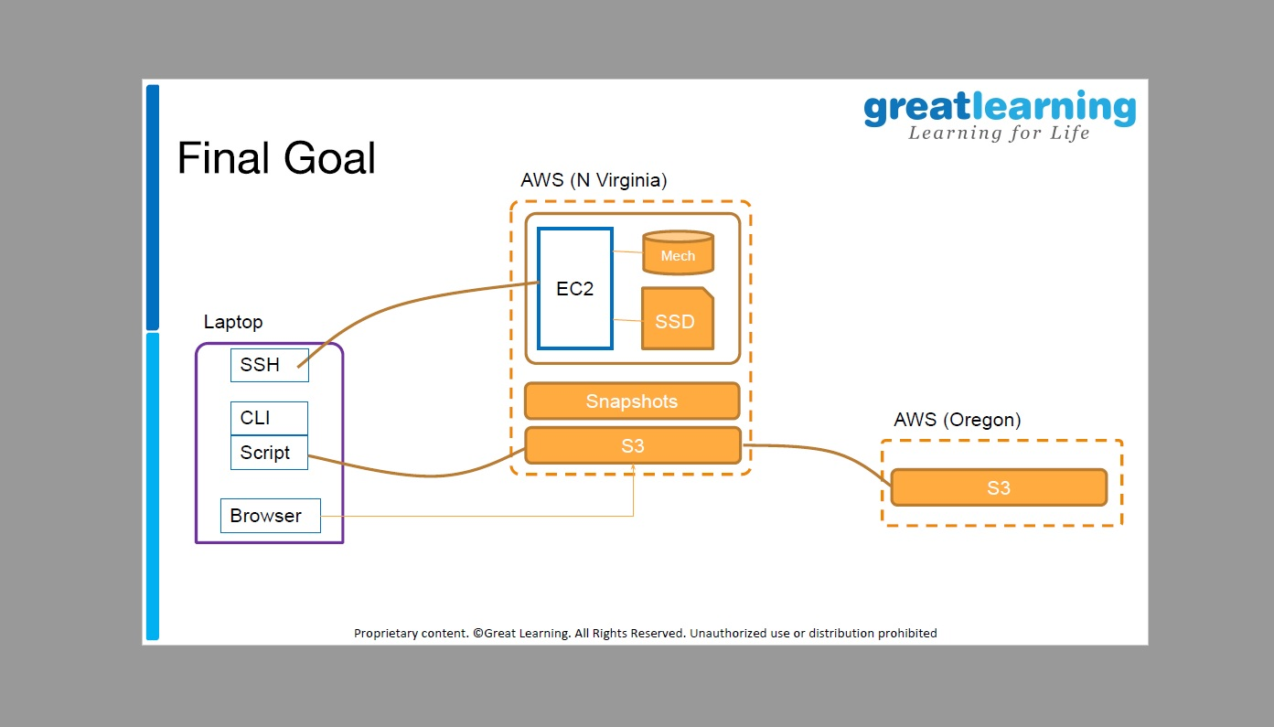

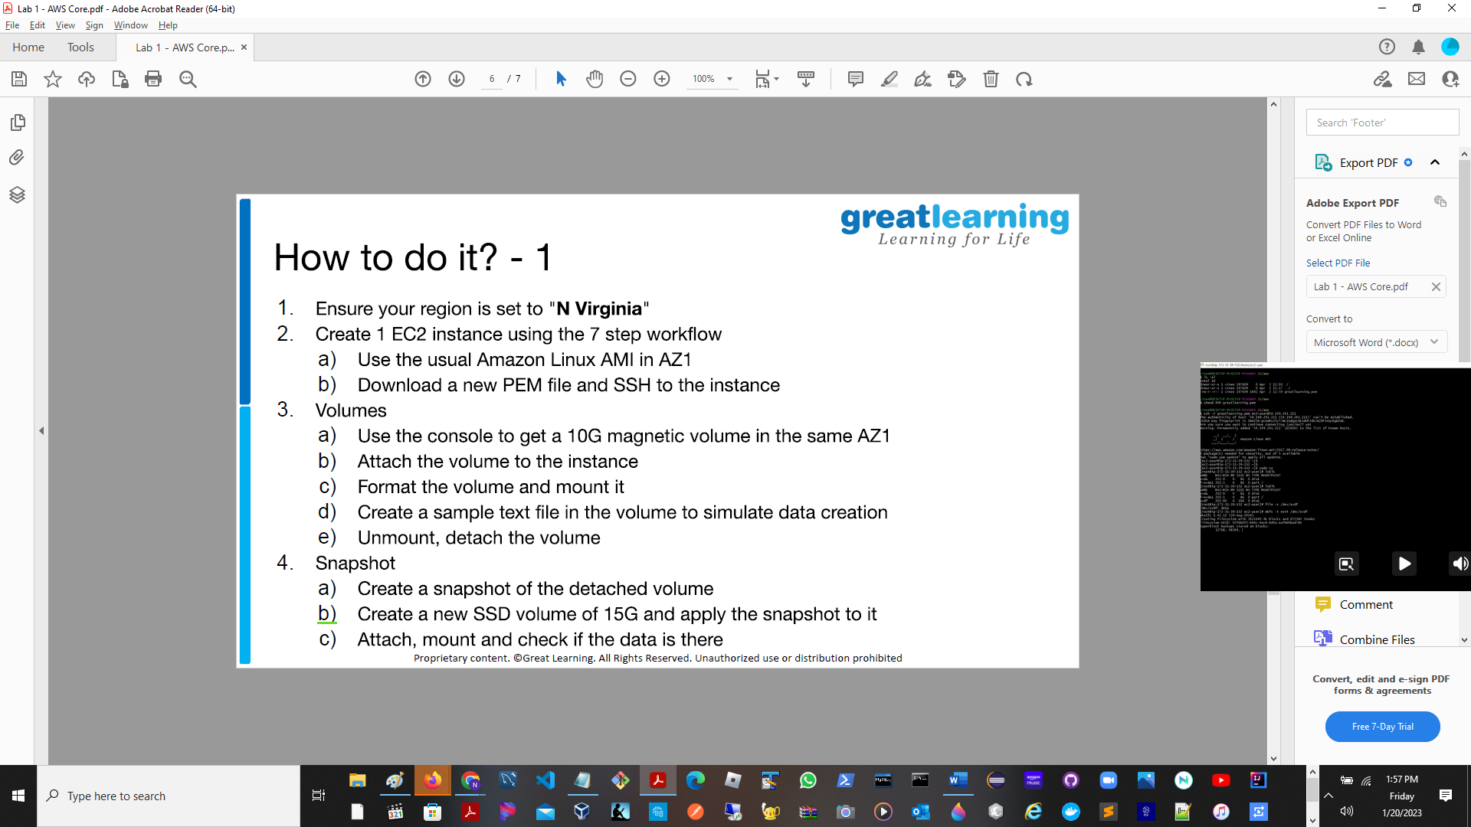

Part 1: EBS

1. Ensure your region is set to “N.Virginia”

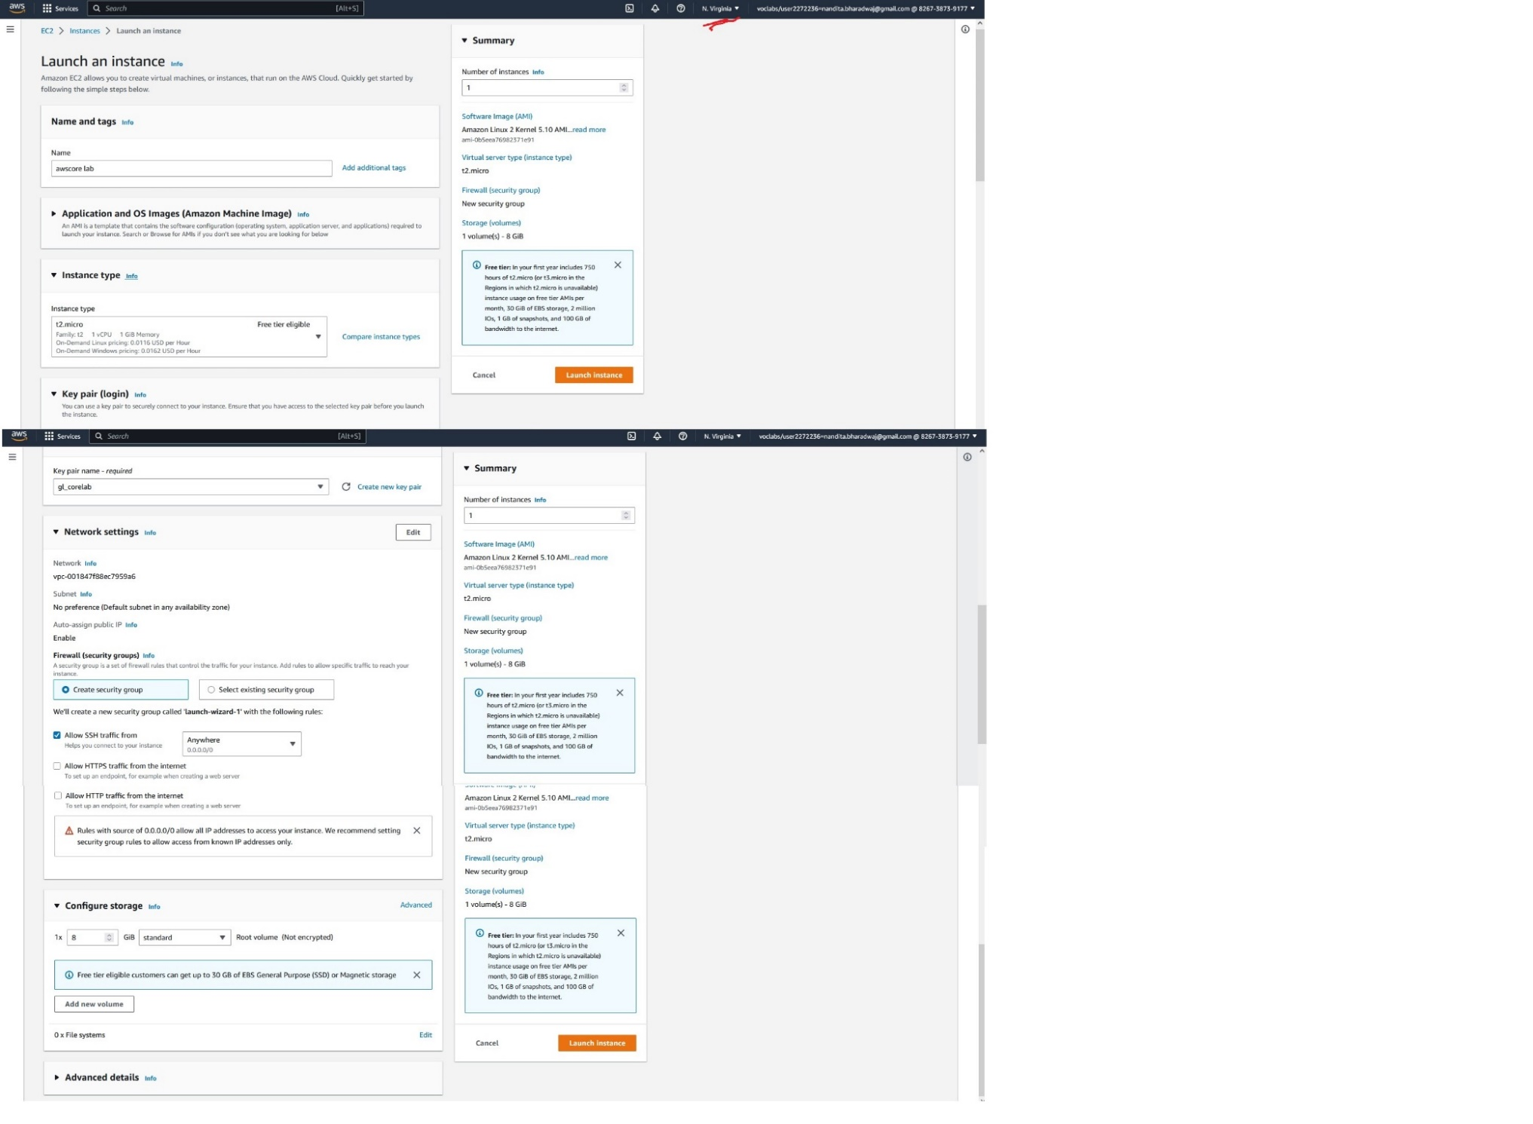

1. Create 1 EC2 instance.
   1. Use Amazon Linux AMI in AZ1

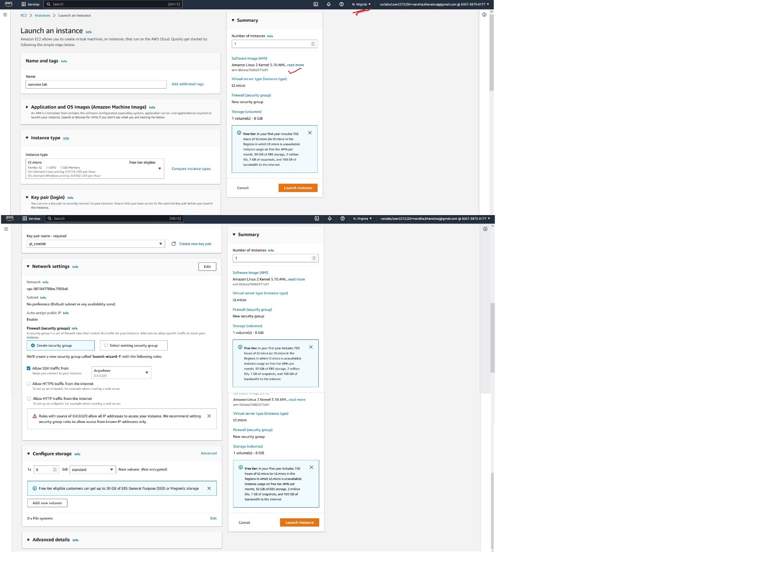

Created EC2 with 8GB magnetic volume.

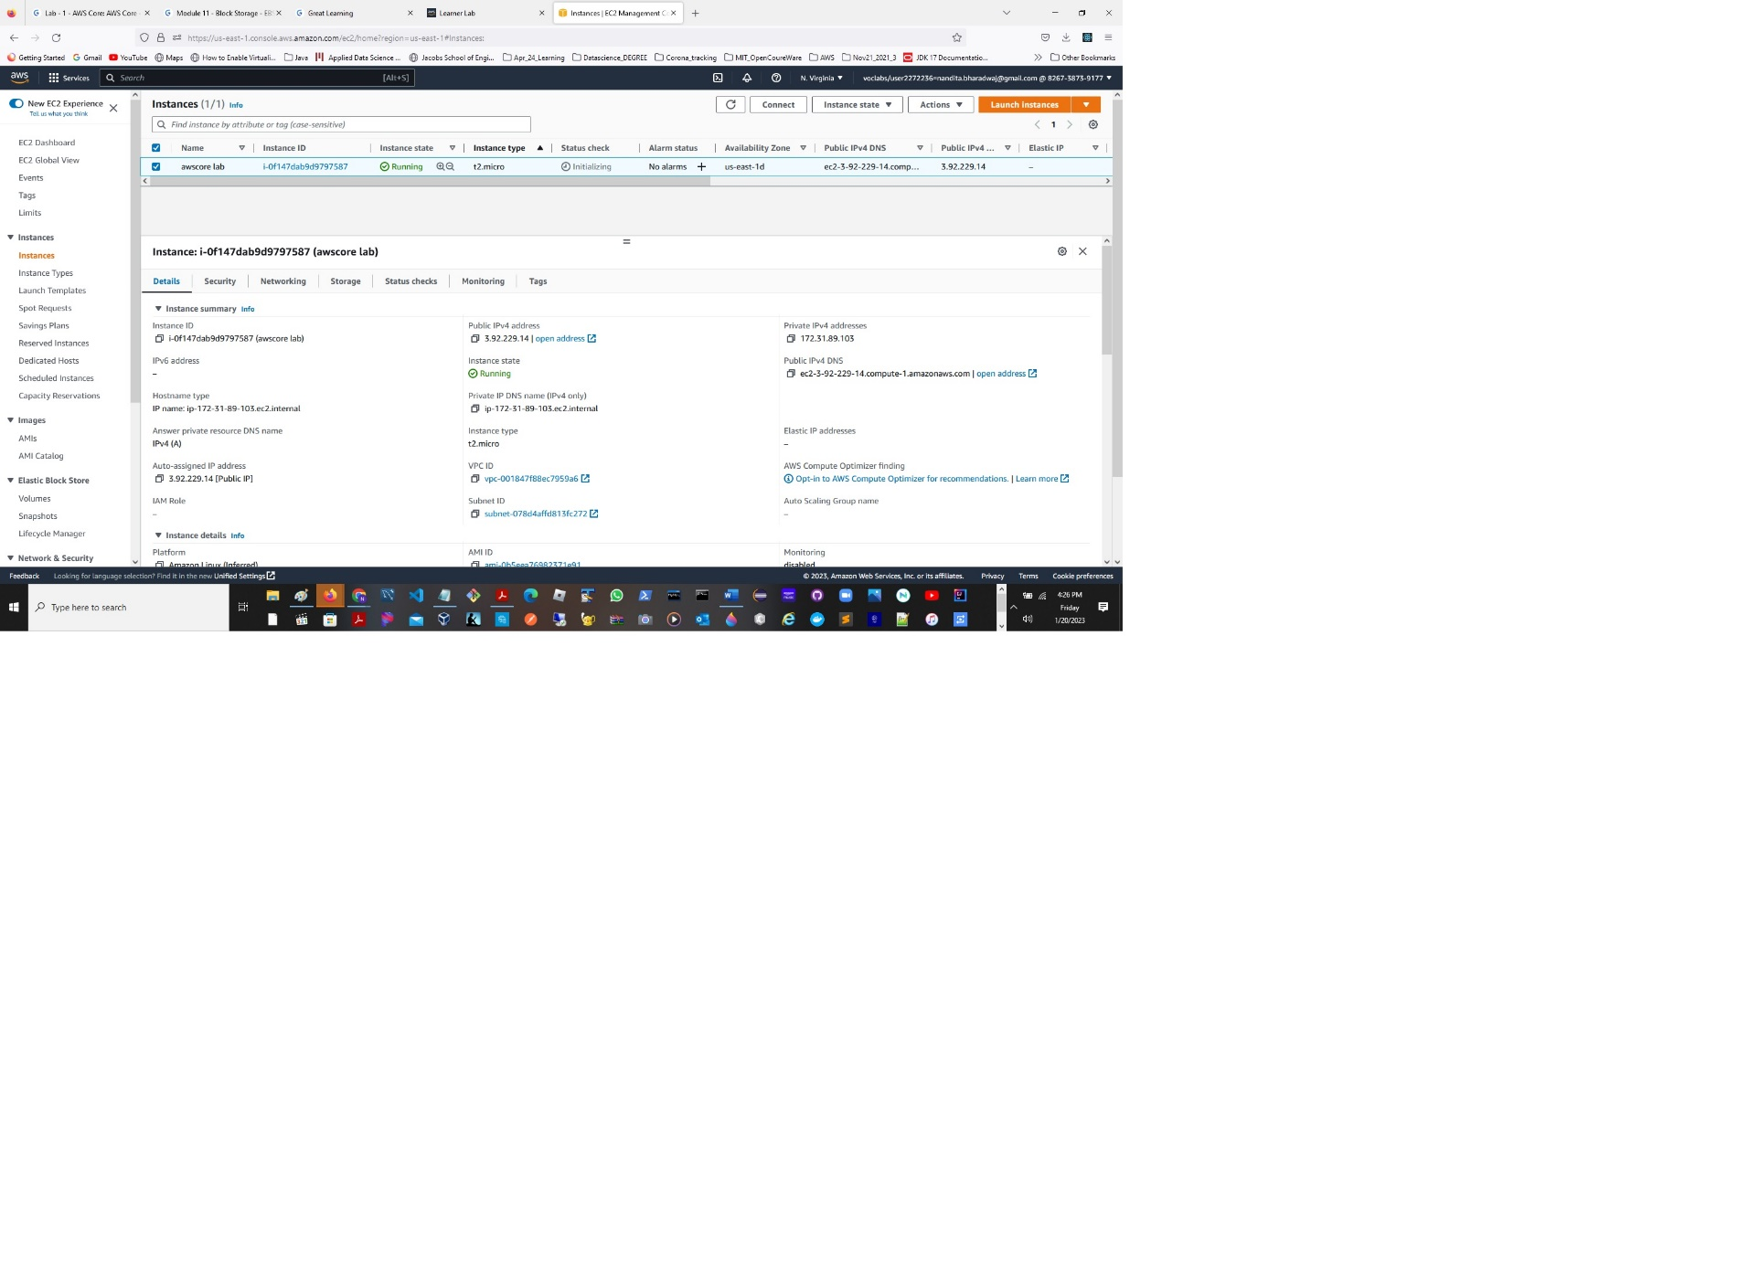

* 1. Download a new PEM file and SSH into instance.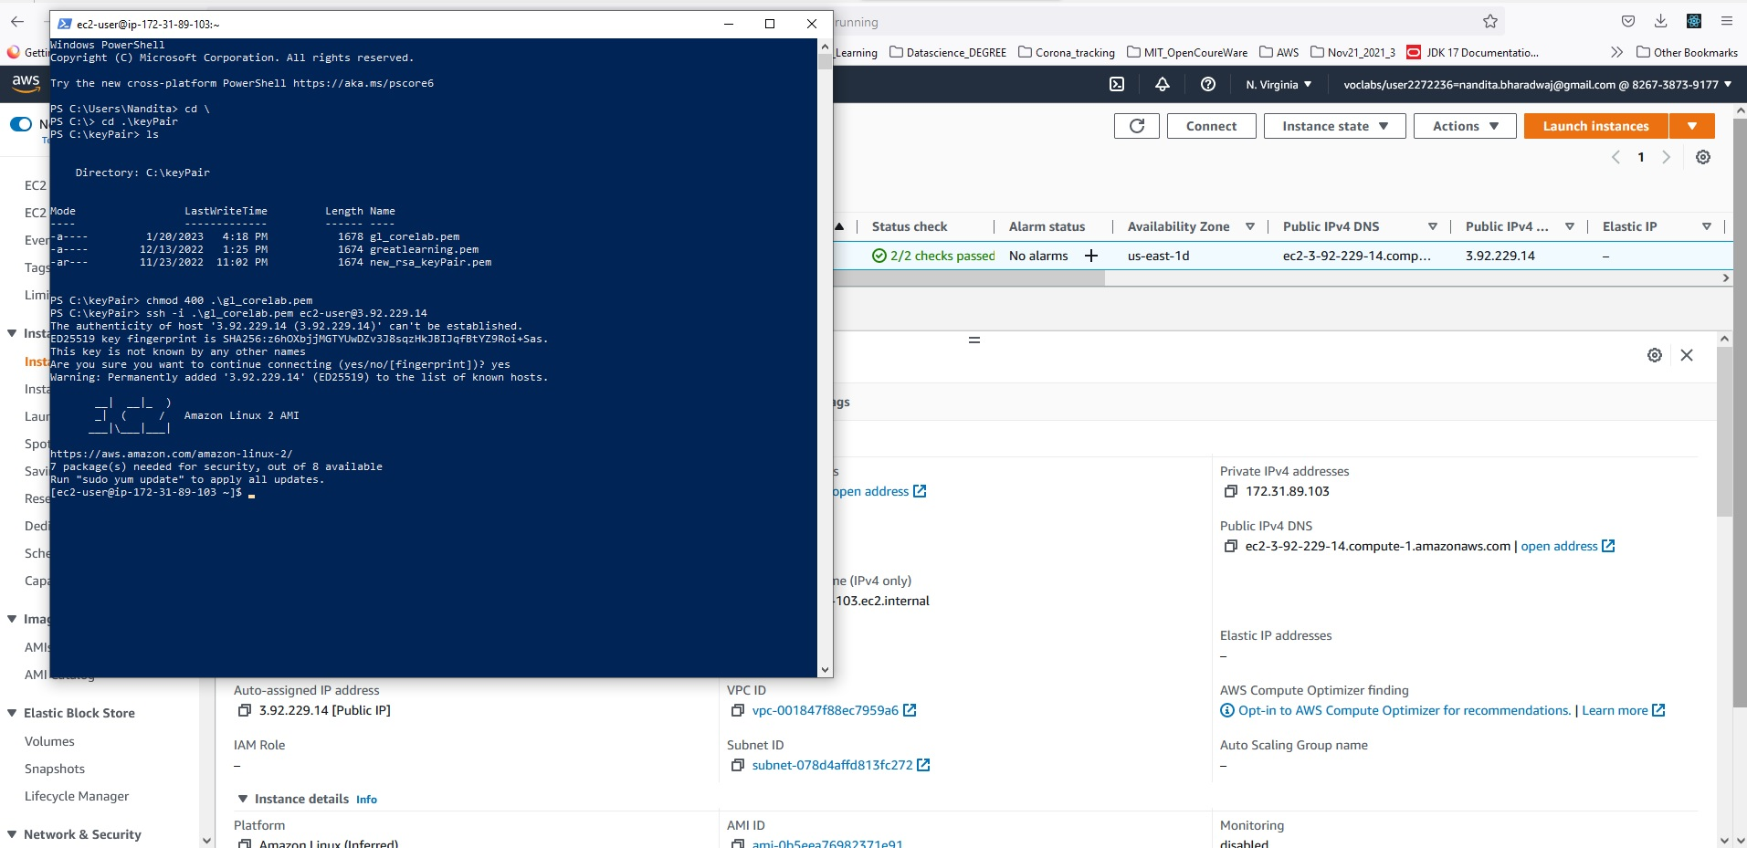

1. Volumes
   1. Use the console to get 10GB magnetic volume in same AZ1

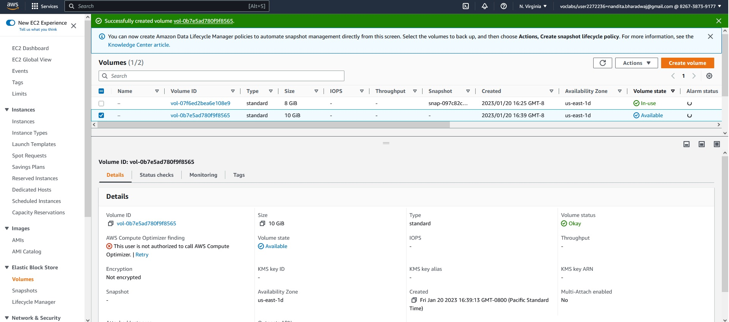

* 1. Attach the volume to the instance.

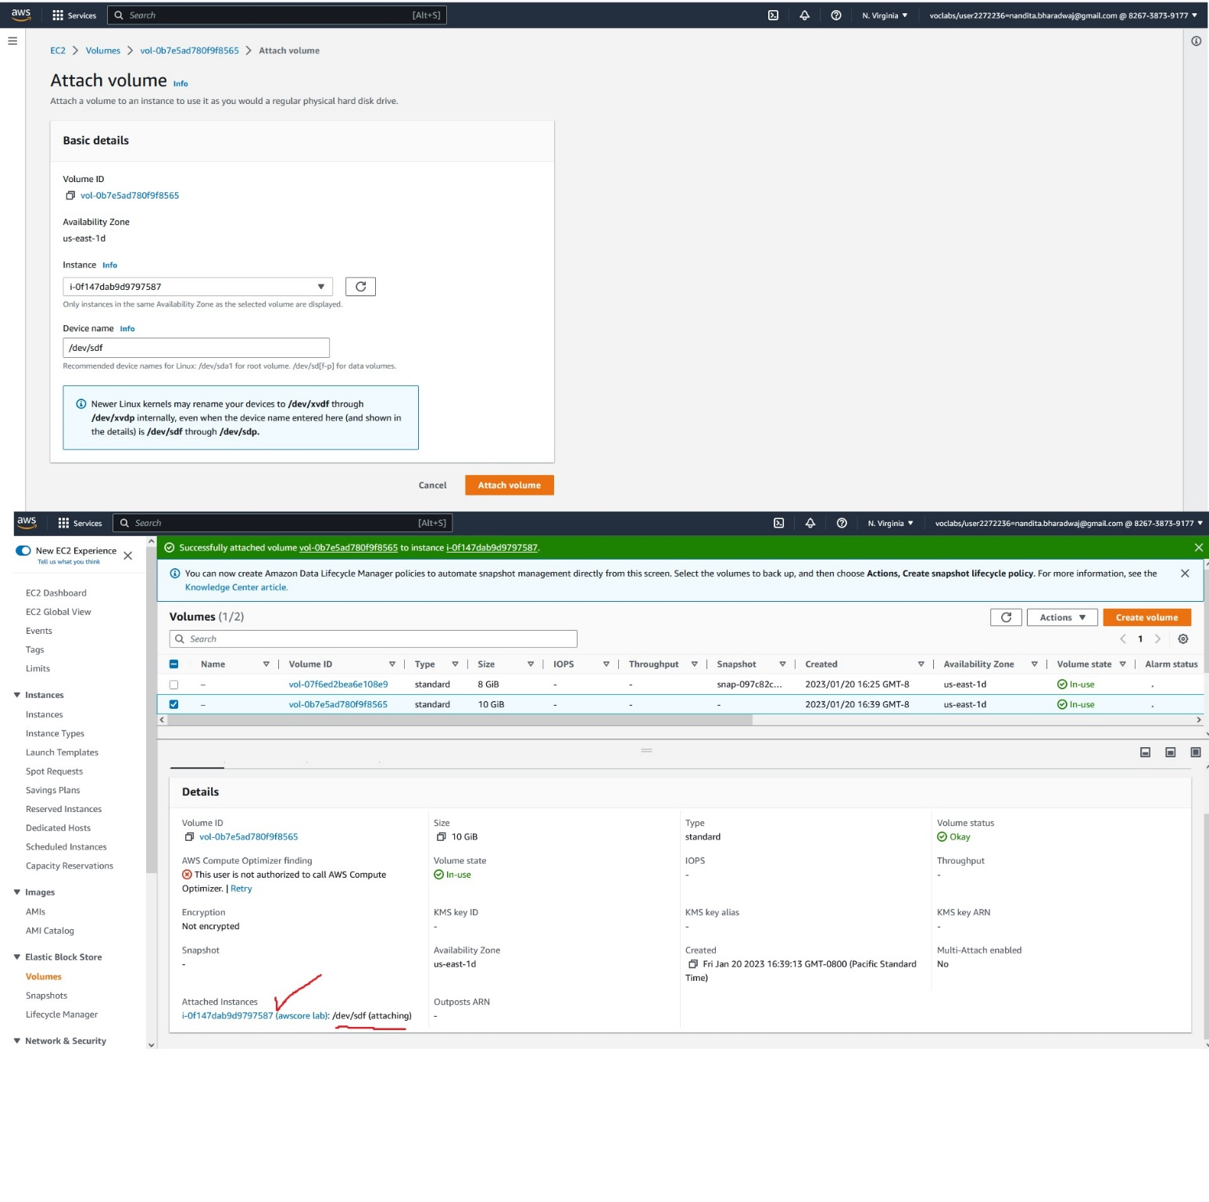

* 1. Format the volume and mount it.

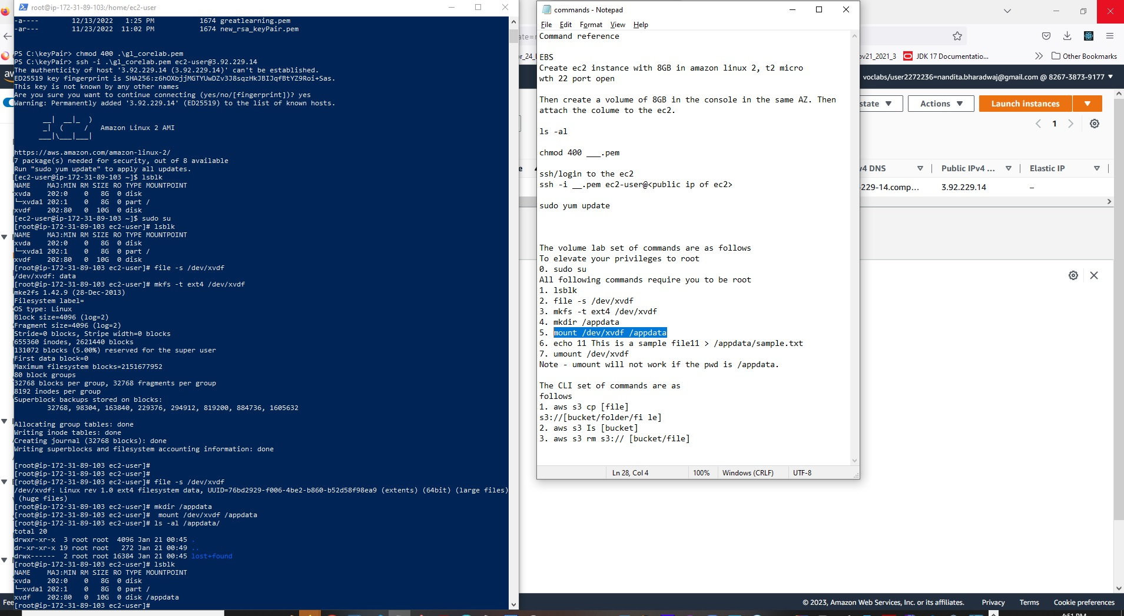

* 1. Create a sample text file in the volume to simulate data creation.

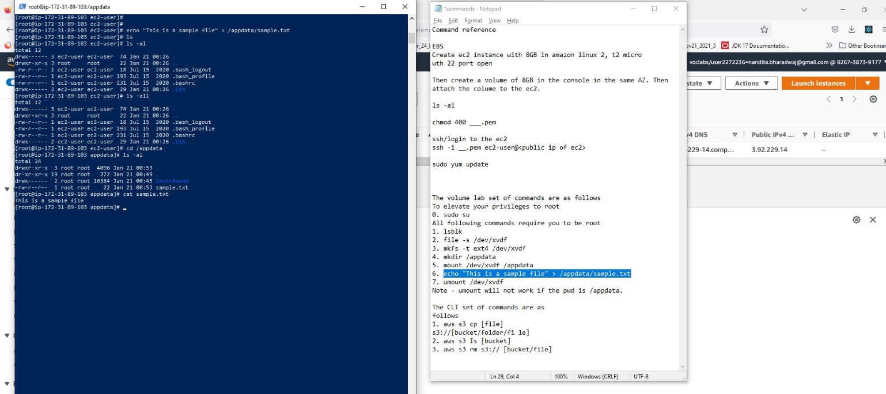

* 1. Unmount, detach the volume.

Unmount the volume.

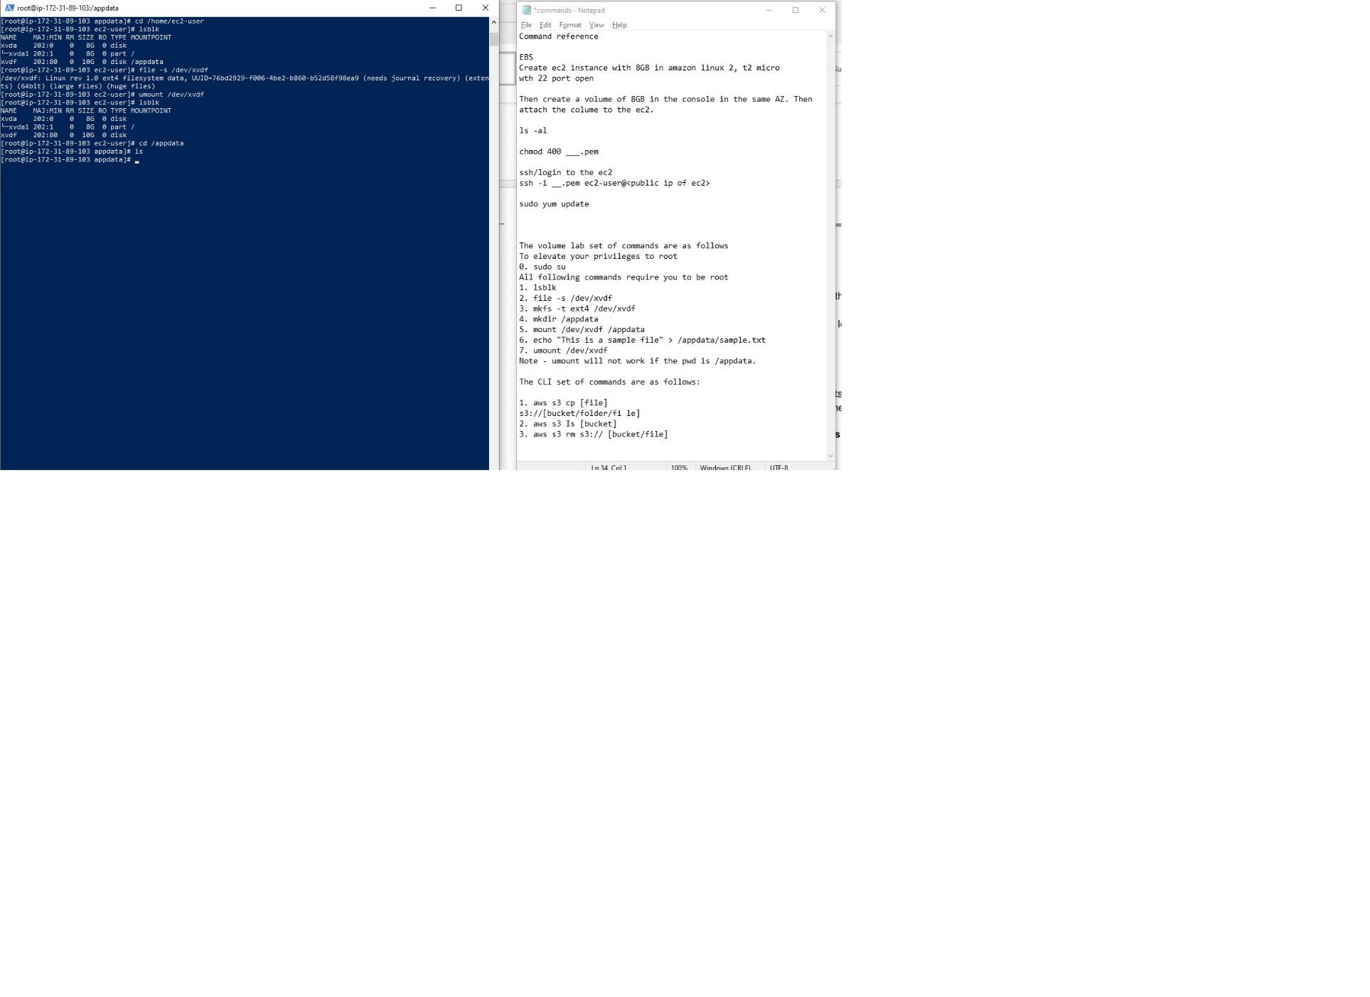

Detach the volume.

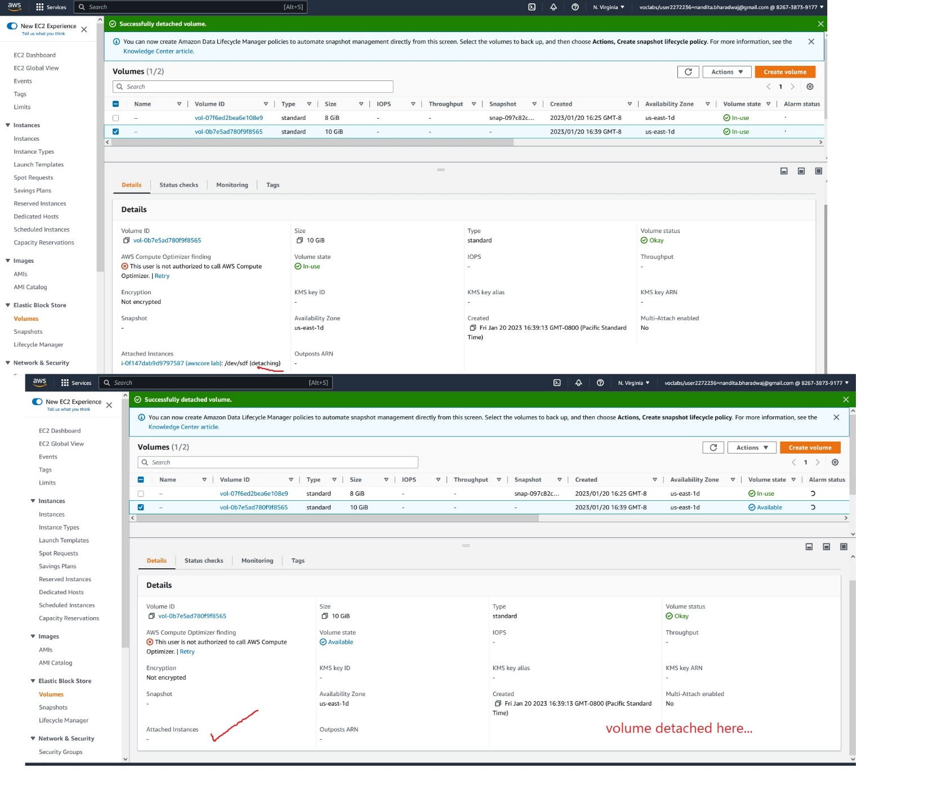

1. Snapshot
   1. Create a snapshot of the detached volume.

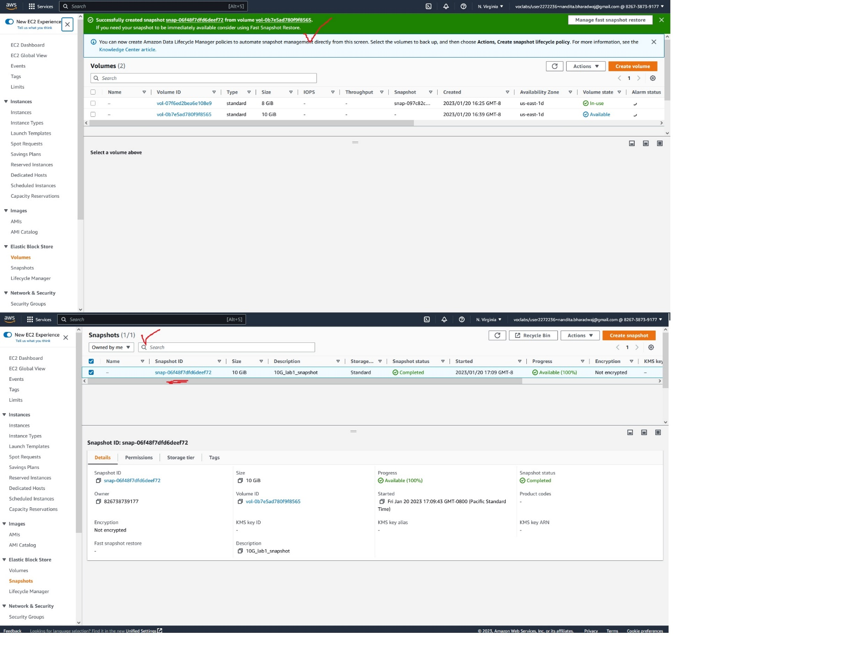

* 1. Create a new SSD volume of 15GB and apply the snapshot to it.

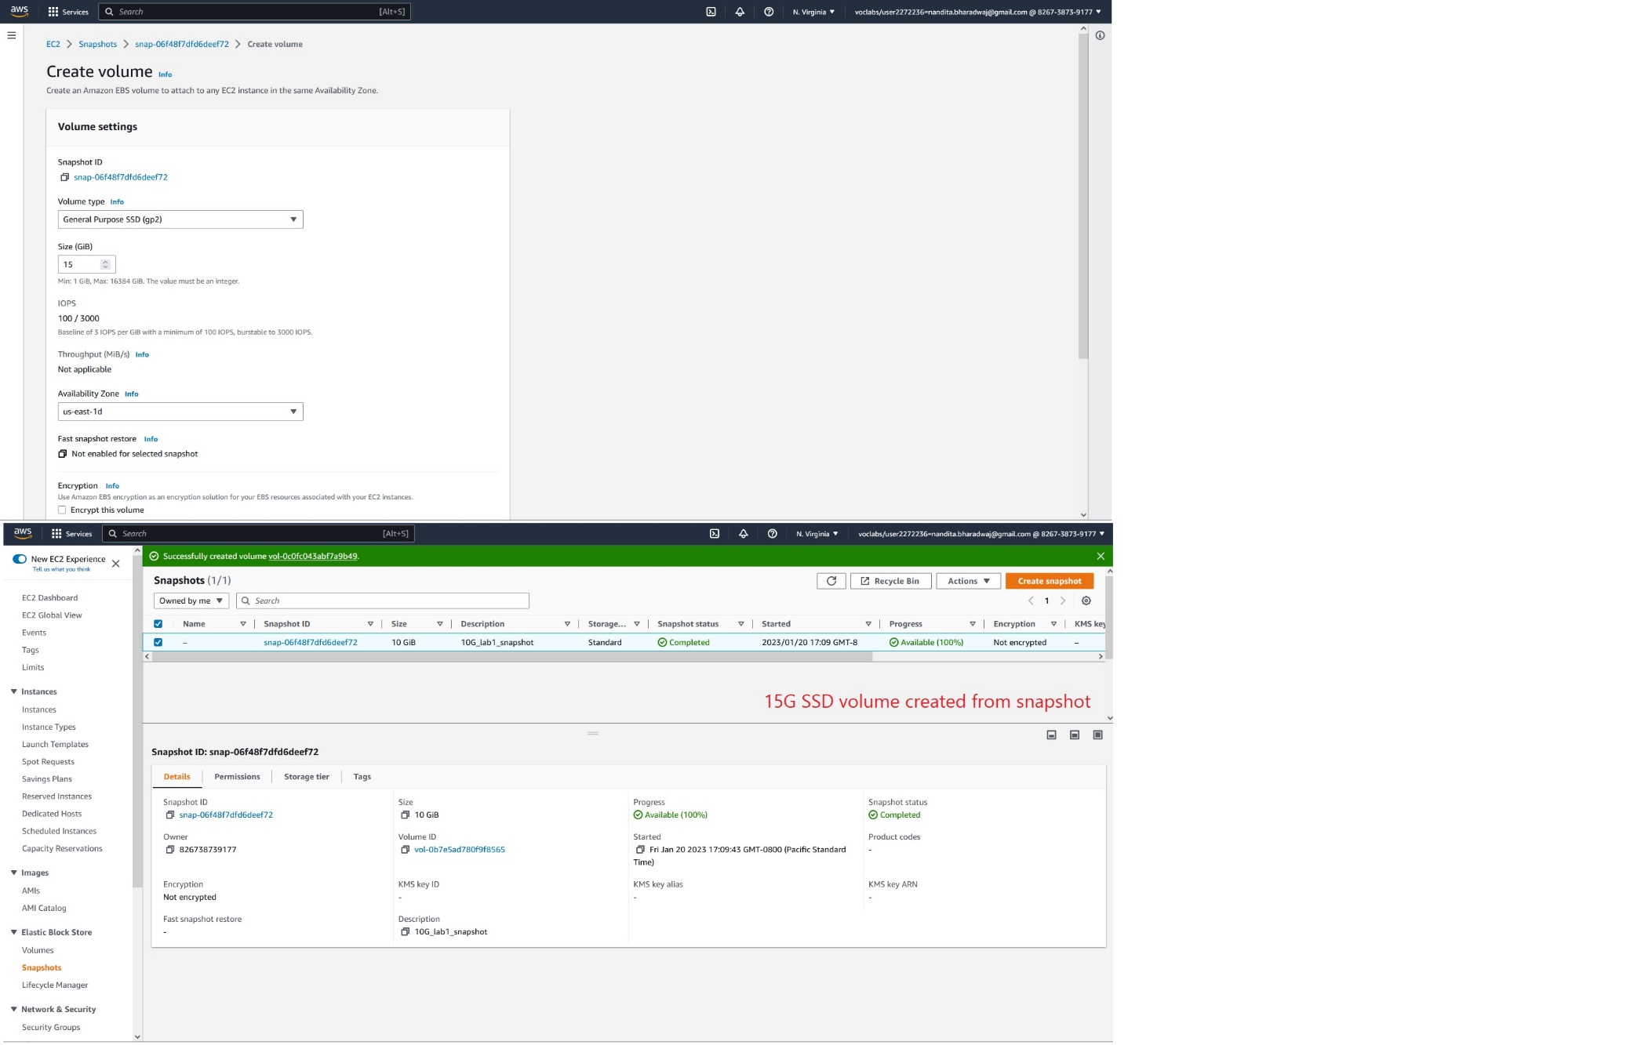

* 1. Attach, mount and check if the data is there.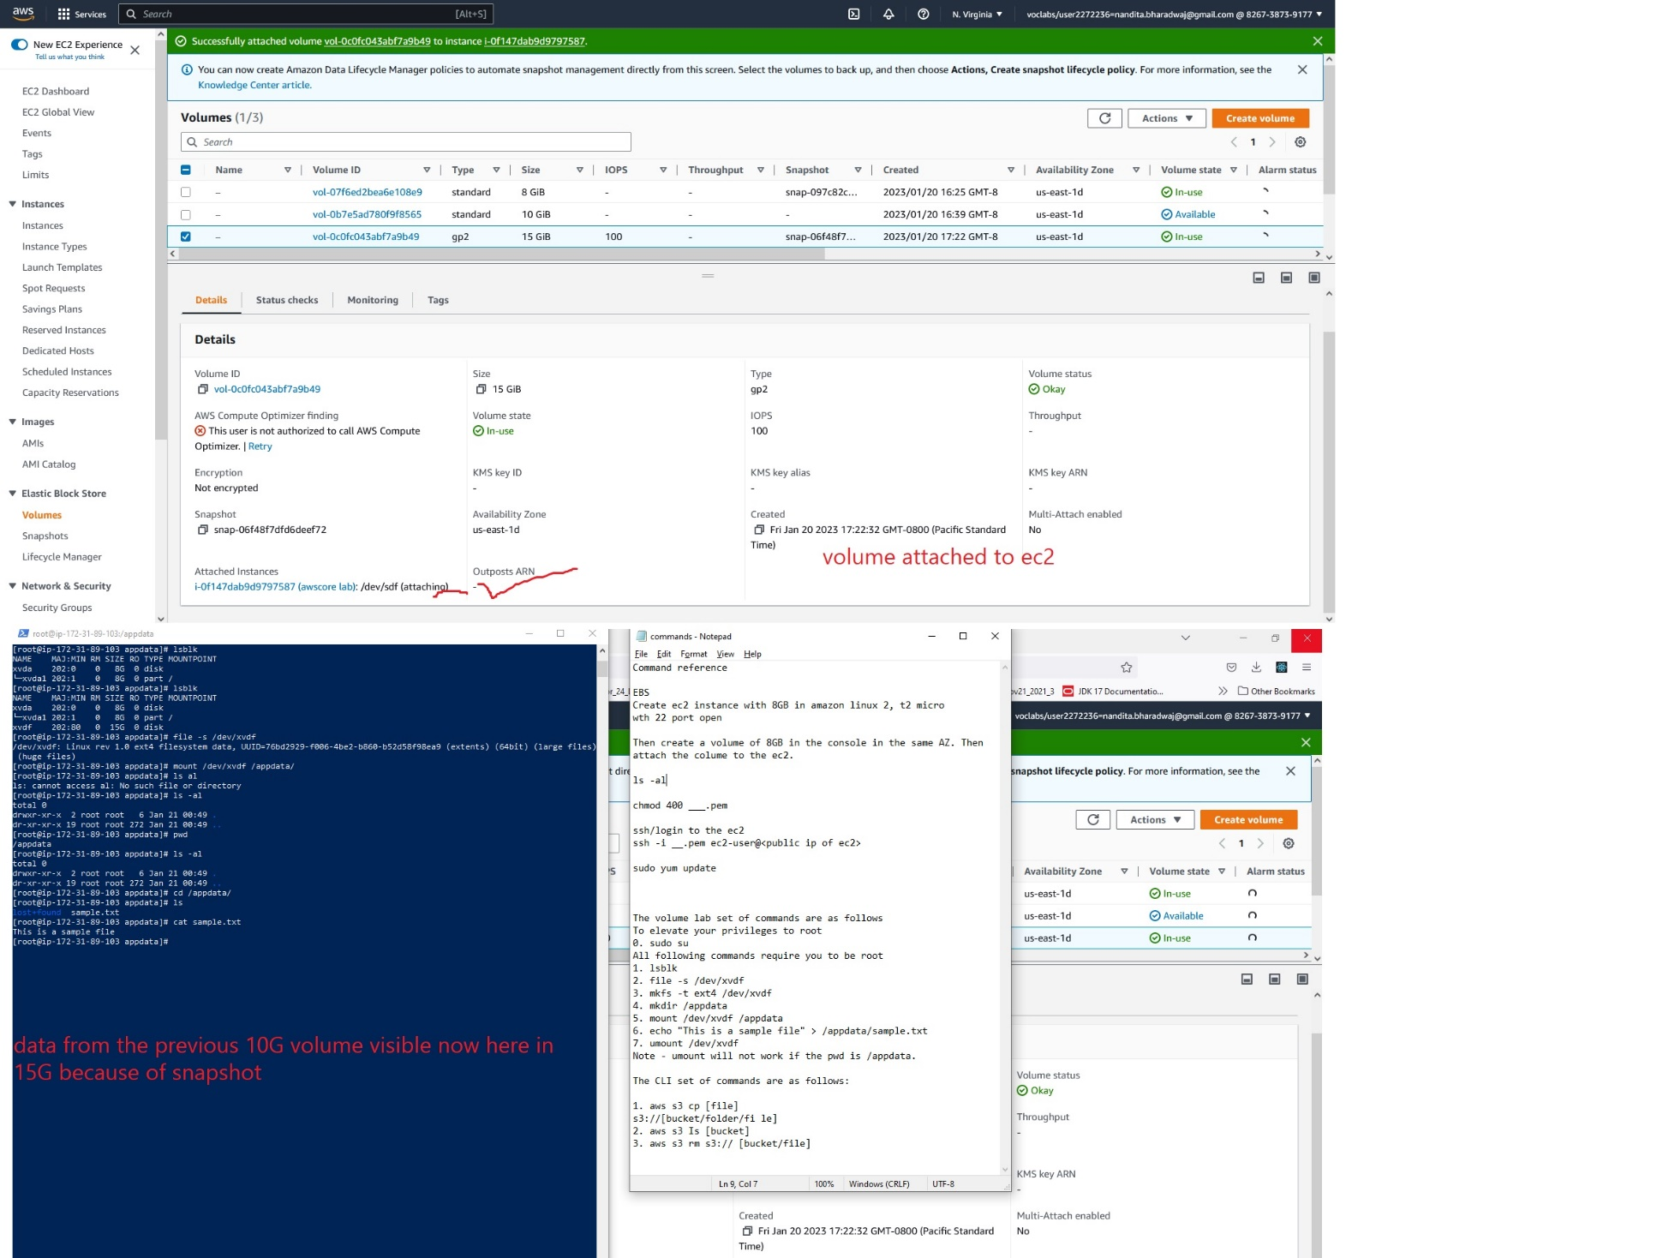

Part 2: S3

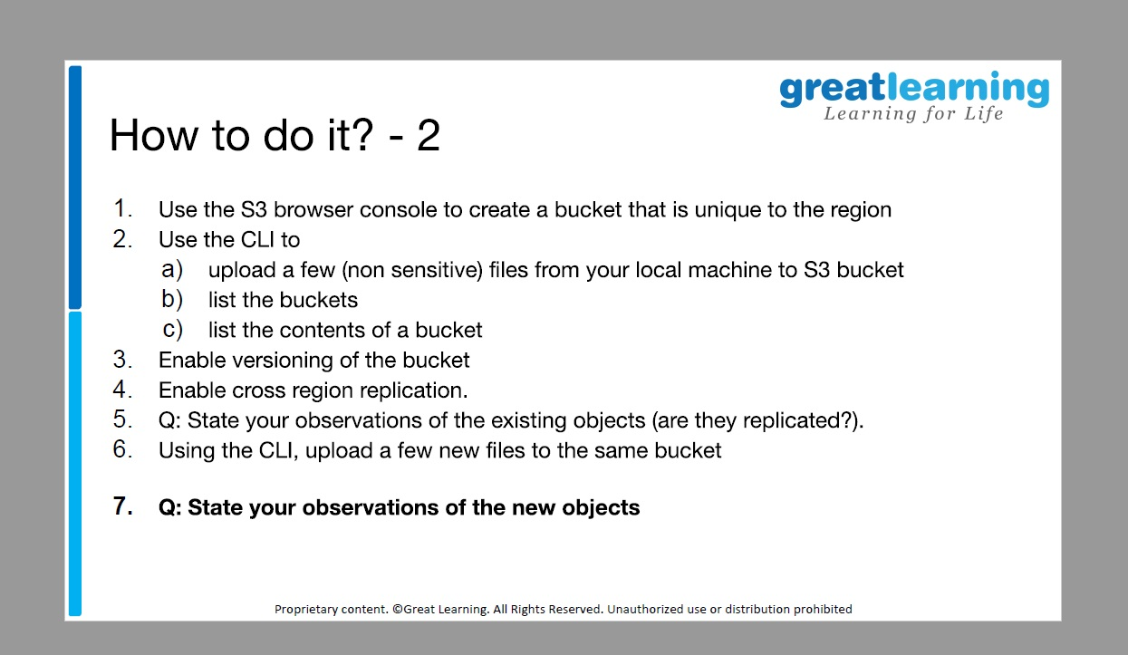

1. Use the S3 bucket console to create a bucket that is unique to the region.

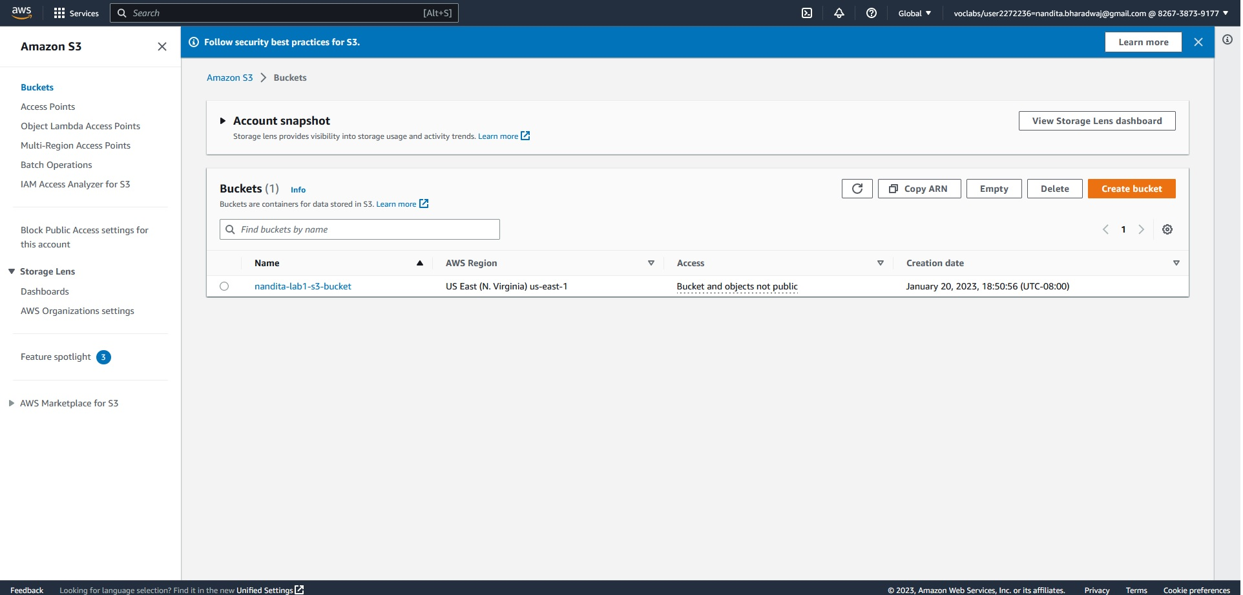

1. Use the CLI to:
   1. Upload a few (non-sensitive) files from your local machine to S3 bucket
   2. List the bucket.
   3. List the contents of a bucket.

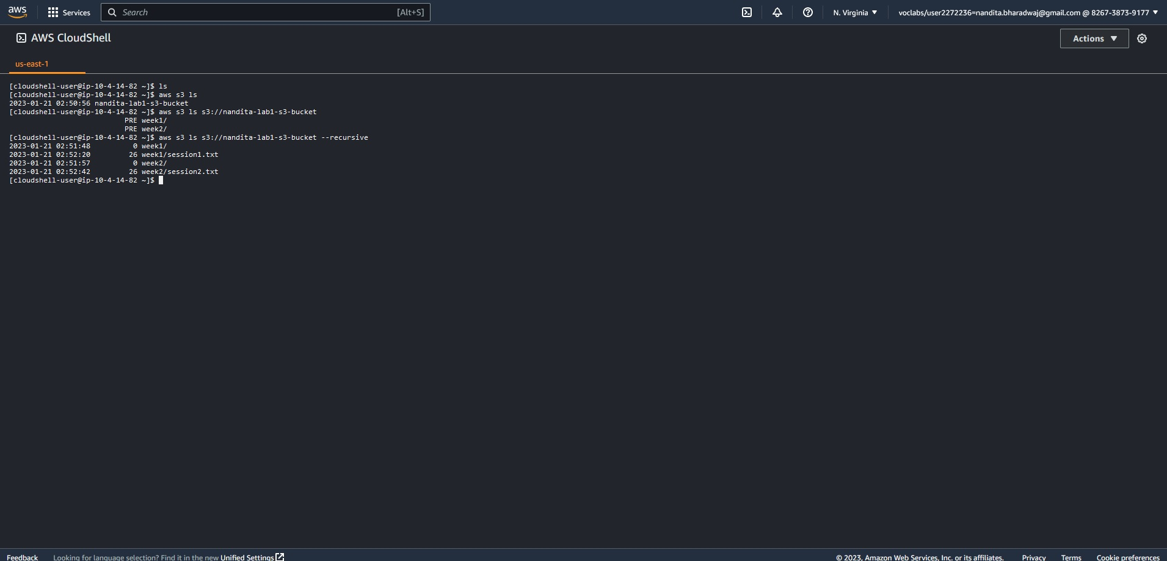

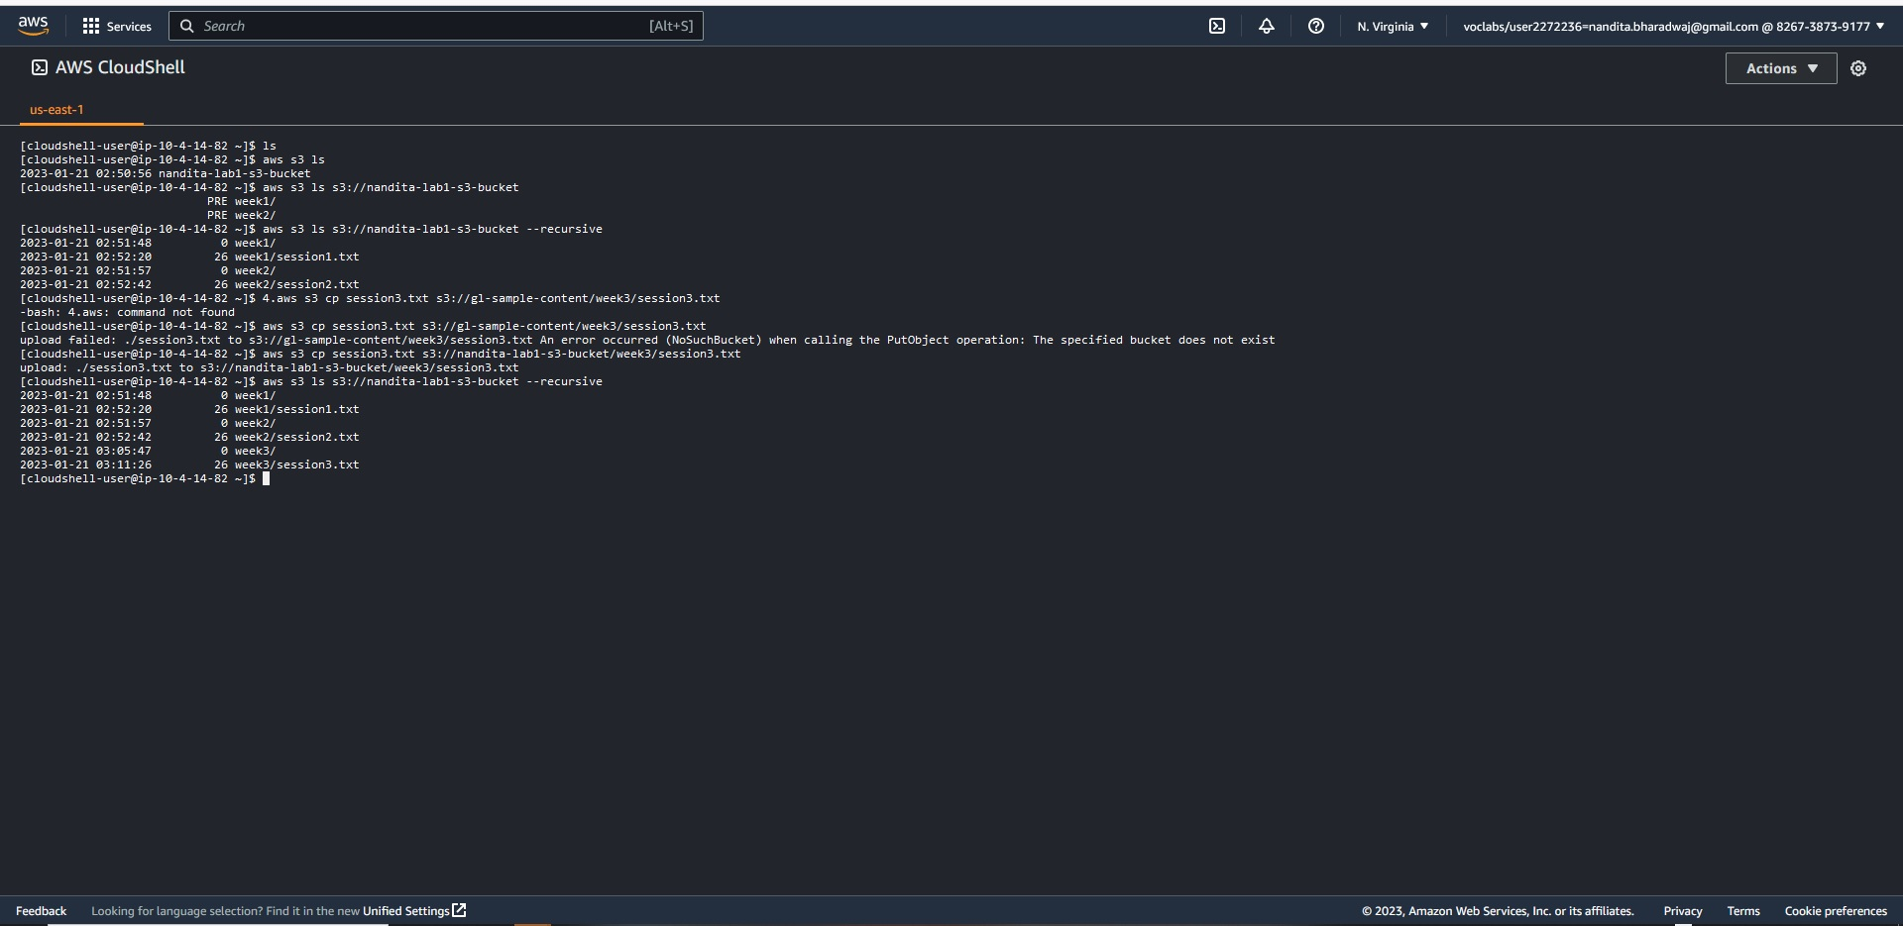

1. Enable versioning of the bucket.

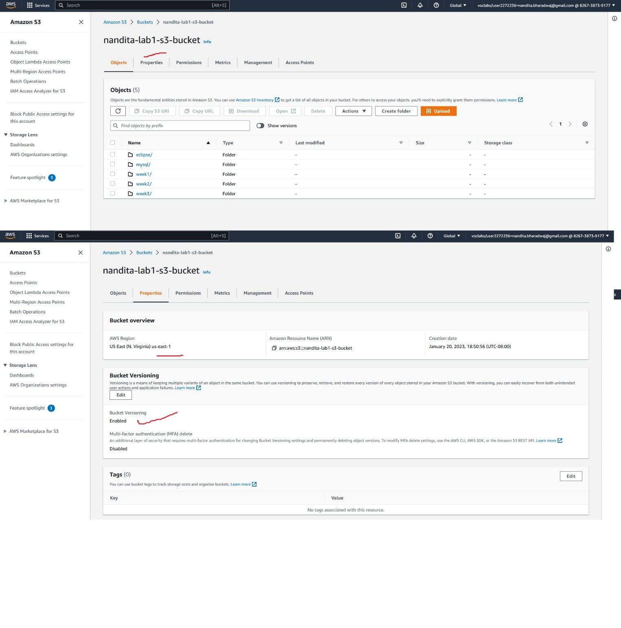

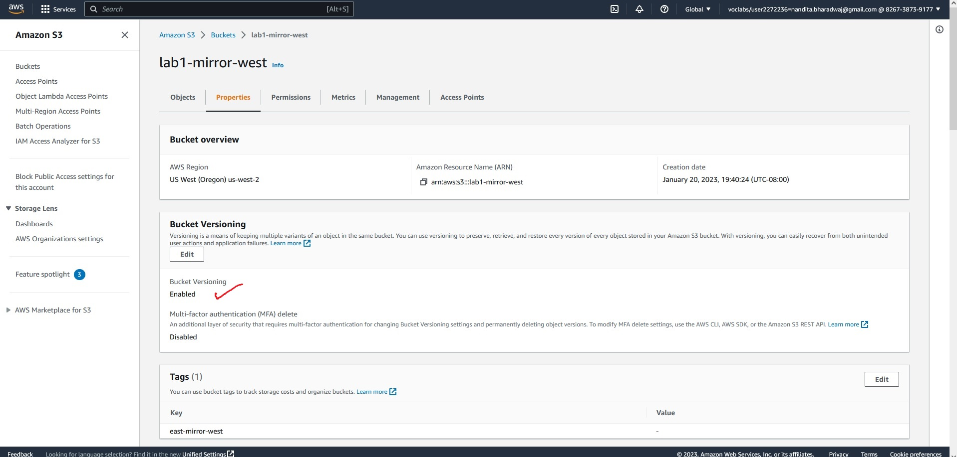

1. Enable cross region replication.

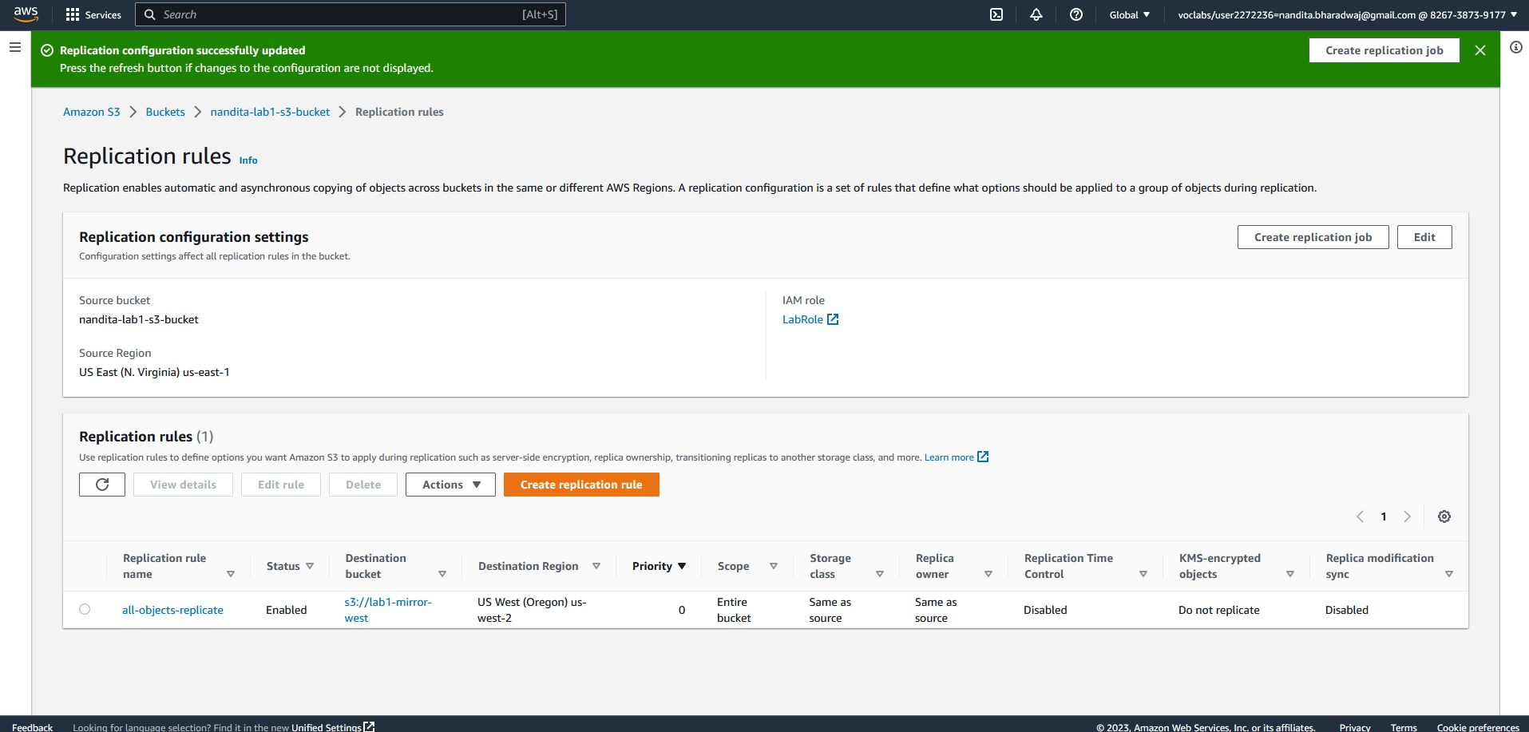

1. Q. State your observations of the existing objects (are they replicated?).

Ans. In aws S3 console, we create the buckets, add files/folders , then create the replication rule, so the mirror s3 bucket will not reflect the earlier added files/ folder or the already existing files in the mirror S3 bucket.

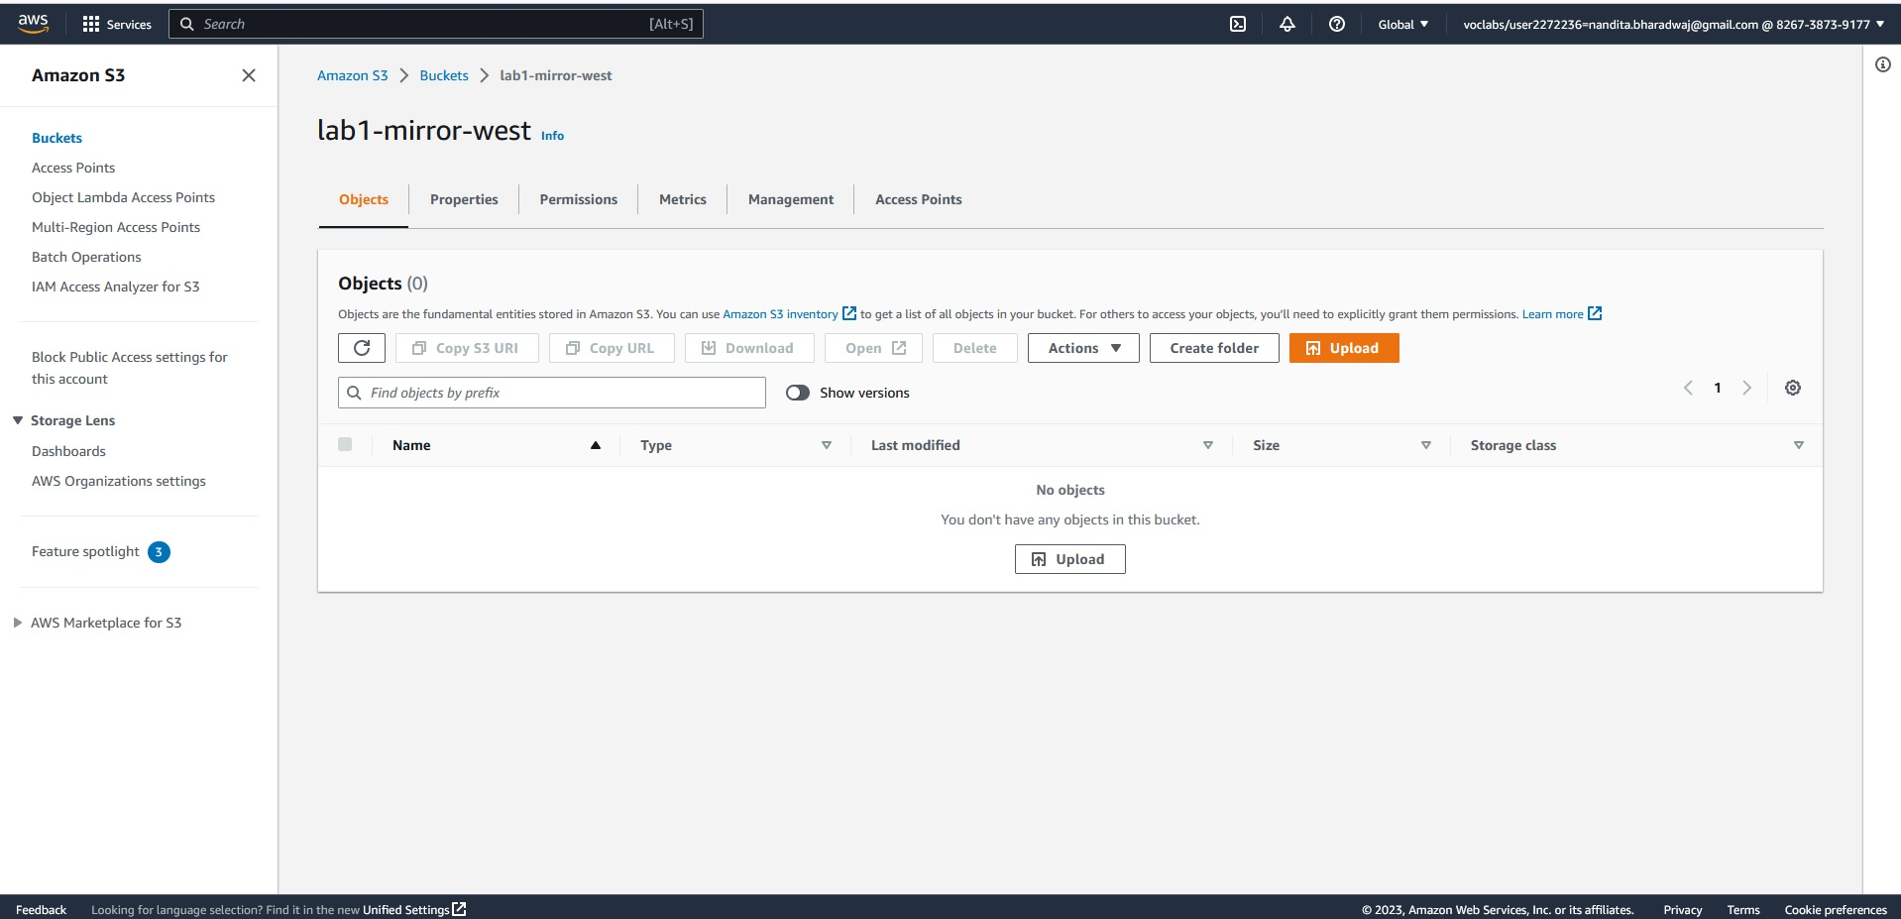

1. Using the CLI, upload a few new files to the same bucket.

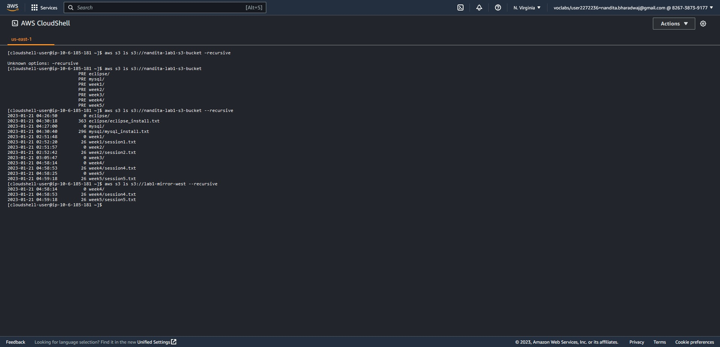

1. Q. State your observations of the new objects.

Ans. The newly added objects/ files and folders are visible in the mirror S3 bucket. So, anything added after the replication rule (in source bucket) will be mirrored into the destination bucket right away (with a min or two).

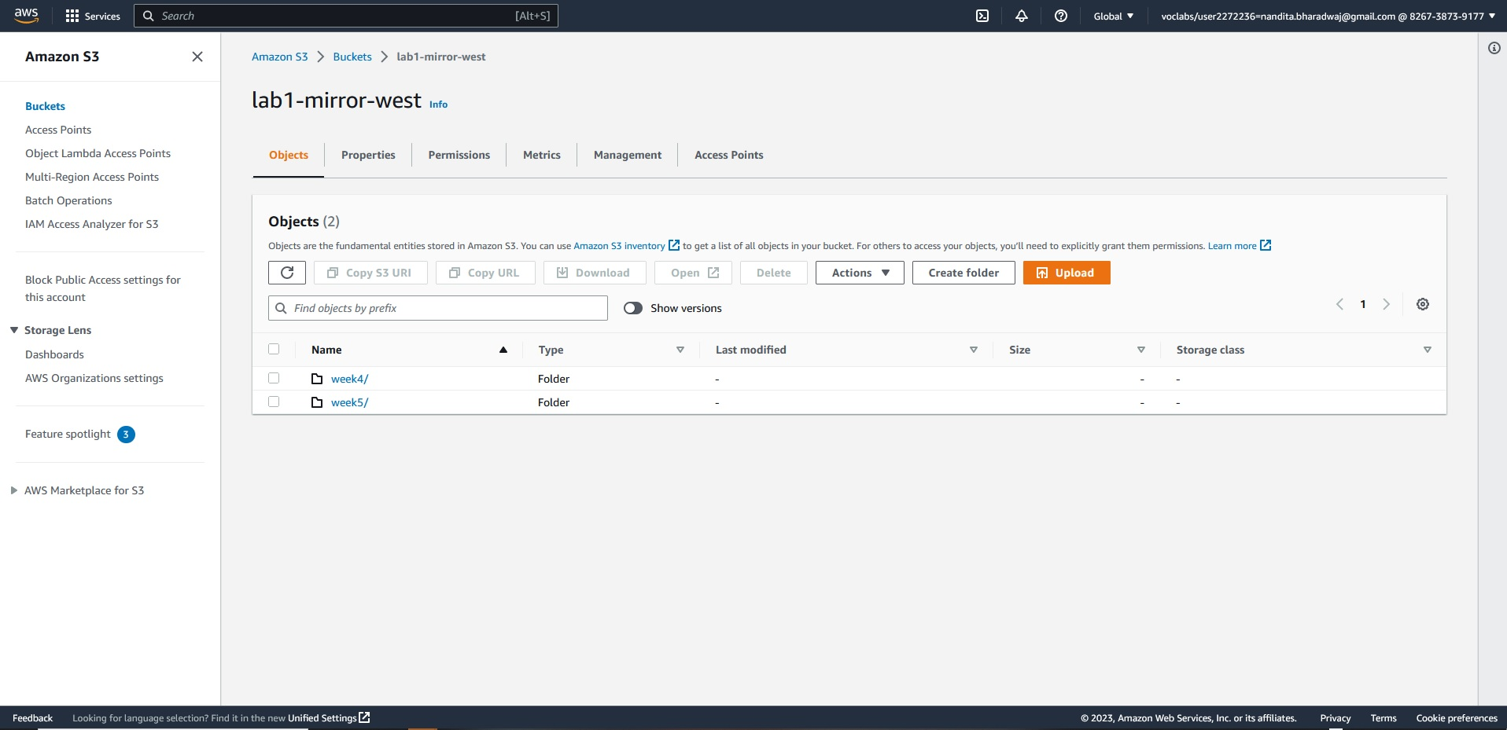

If a folder is created in source file before adding replication rule in source bucket, and a file is added to that folder after creating the replication rule, the file is mirrored in the S3 bucket with the existing folder uploaded.

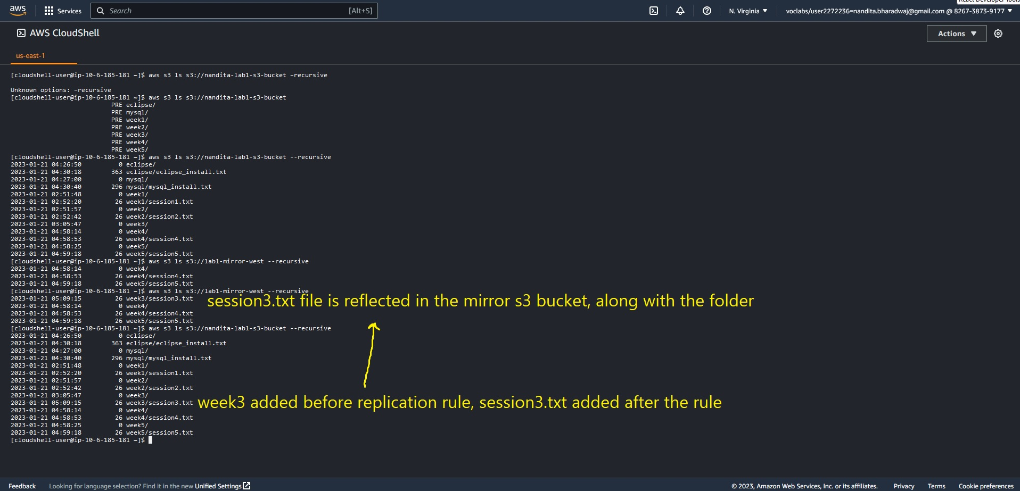

If a file is directly uploaded to the bucket without a folder, also replicated.

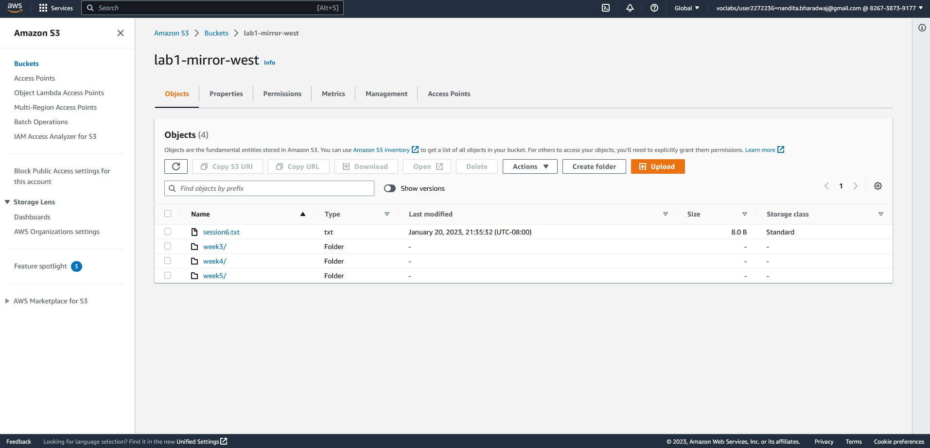

Files deleted in the bucket is NOT replicated (removed).

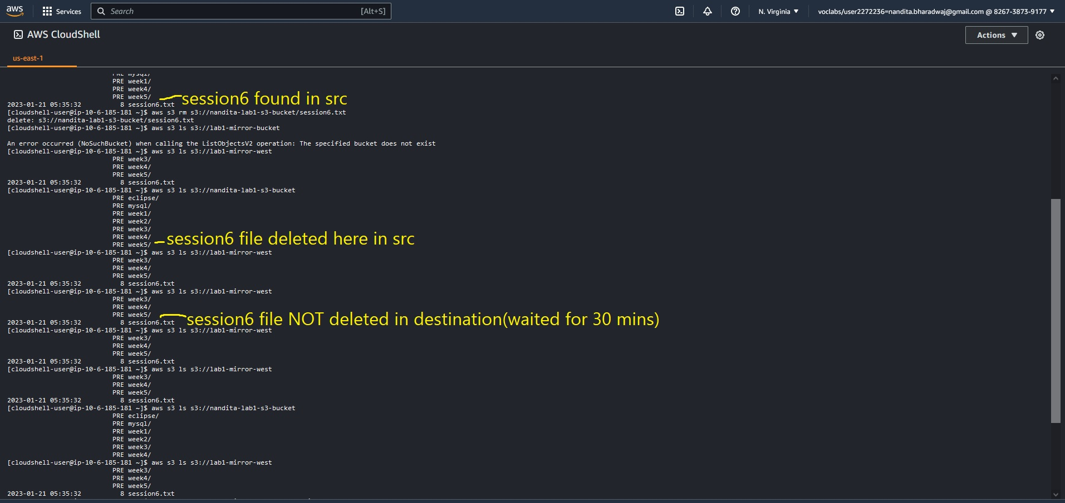

New replication rule created to only allow replication with folder having prefix of “mysql”

The older replication rule disabled, and new replication rule is enabled.

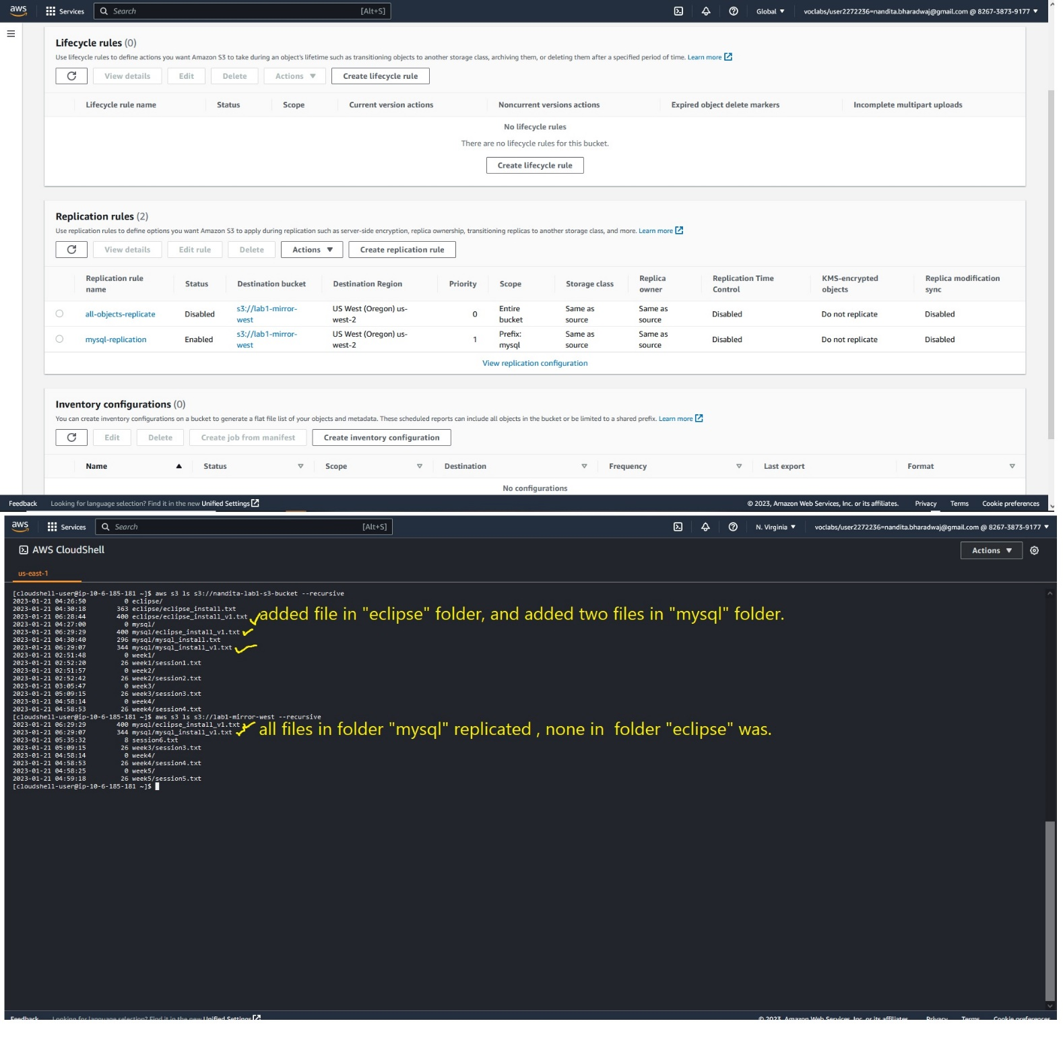

**Command reference**

The “volume” lab set of commands are as follows

To elevate your privileges to root

0. sudo su

All following commands require you to be root

1. lsblk

2. file -s /dev/xvdf

3. mkfs -t ext4 /dev/xvdf

4. mkdir /appdata

5. mount /dev/xvdf /appdata

6. echo “This is a sample file” > /appdata/sample.txt

7. umount /dev/xvdf

Note - umount will not work if the pwd is /appdata.

The CLI set of commands are as

follows

1. aws s3 cp [file]

s3://[bucket/folder/file]

2. aws s3 Is [bucket]

3. aws s3 rm s3:// [bucket/file]

New commands

1. aws s3 ls
2. aws s3 ls s3://<bucket-name>
3. aws s3 ls s3://<bucket-name> –recursive

upload file to amazon cloudshell context

1. aws s3 cp session3.txt s3://<bucket-name>/week3/session3.txt
2. aws s3 rm s3://<bucket-name>/week3/session3.txt